Usig the lm( )-function in R fit the 2-factor-model of the first lecture in linear
modelling:
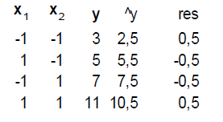
Calculate coefficients, predictions, residuals for the linear model.
Then calculate coeffients for the interaction model.
What happens if you change x values to 20 instead of -1 and 40 instead of +1 for x1
and to 20 instead of -1 and 30 instead of +1 for x2?
Have the coefficients changed? Have the predictions changed?

